What is Data?

Data is nothing but facts and statistics stored or free flowing over a network, generally it's raw and unprocessed. For example: When you visit any website, they might store you IP address, that is data, in return they might add a cookie in your browser, marking you that you visited the website, that is data, your name, it's data, your age, it's data.

Data becomes information when it is processed.

**Types of data :**

Categorical , discrete and continuous

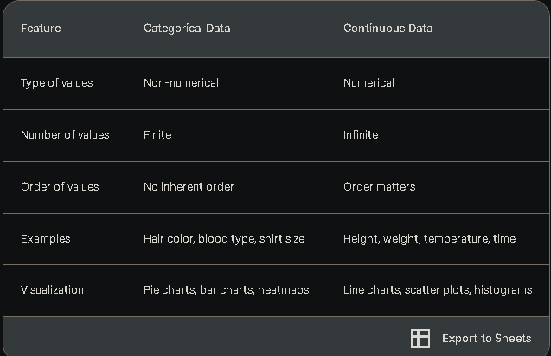

Here's a clear explanation of the difference between discrete and continuous data, along with examples:

**Discrete data** consists of distinct, countable values that can't be subdivided into smaller units. It often involves integers (whole numbers) and represents items that can be counted.

Examples of discrete data:

* Number of students in a class (e.g., 25)
* Number of cars sold in a month (e.g., 120)
* Shoe size (e.g., 8, 9, 10)
* Number of pets owned (e.g., 0, 1, 2, 3)
* Number of goals scored in a game (e.g., 3)
* Number of items in a shopping cart (e.g., 5)

**Continuous data,** on the other hand, can take on any value within a given range, even values that include decimals or fractions. It represents measurements or quantities that can be divided into smaller and smaller units.

Examples of continuous data:

* Height (e.g., 1.75 meters)
* Weight (e.g., 65.3 kilograms)
* Time (e.g., 2.5 hours)
* Temperature (e.g., 23.7 degrees Celsius)
* Distance (e.g., 100.2 kilometers)
* Speed (e.g., 60.5 kilometers per hour)
* Age (e.g., 25.8 years)

Key differences:

* Values: Discrete data has distinct, separate values, while continuous data can take on any value within a range.
* Countability: Discrete data can be counted, while continuous data cannot be counted but can be measured.
* Measurement: Discrete data is often measured using whole numbers, while continuous data is often measured using decimals or fractions.
* Visualization: Discrete data is often visualized using bar charts or pie charts, while continuous data is often visualized using line charts, scatter plots, or histograms.

**Uses of charts based on specification of data:**  
Here are some common data visualization charts, the types of data they're best suited for, and examples of their use:

1. Bar Charts:

* Data: Categorical or discrete data, comparisons between categories.
* Use Cases:
  + Comparing sales figures for different products.
  + Showing population distribution across regions.
  + Illustrating survey responses.

[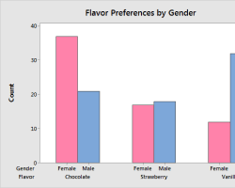Opens in a new window[](https://statisticsbyjim.com/graphs/bar-charts/)statisticsbyjim.com](https://statisticsbyjim.com/graphs/bar-charts/)

Bar chart example

2. Line Charts:

* Data: Continuous data over time, trends, patterns.
* Use Cases:
  + Tracking temperature changes over a day.
  + Visualizing stock prices over a year.
  + Monitoring website traffic growth.

[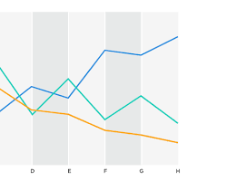Opens in a new window[](https://www.jaspersoft.com/articles/what-is-a-line-chart)www.jaspersoft.com](https://www.jaspersoft.com/articles/what-is-a-line-chart)

Line chart example

3. Pie Charts:

* Data: Parts of a whole, proportions.
* Use Cases:
  + Showing budget allocation for different departments.
  + Illustrating market share for various companies.
  + Representing the composition of a population by age group.

[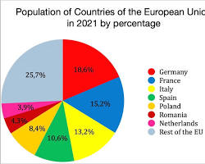Opens in a new window[](https://www.writing.support/piechart1.htm)www.writing.support](https://www.writing.support/piechart1.htm)

Pie chart example

4. Scatter Plots:

* Data: Relationships between two numerical variables.
* Use Cases:
  + Exploring correlations between height and weight.
  + Analyzing the relationship between study hours and exam scores.
  + Investigating patterns in customer spending habits.

[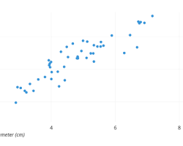Opens in a new window[](https://chartio.com/learn/charts/what-is-a-scatter-plot/)chartio.com](https://chartio.com/learn/charts/what-is-a-scatter-plot/)

Scatter plot example

5. Histograms:

* Data: Distribution of continuous data.
* Use Cases:
  + Showing the distribution of test scores.
  + Visualizing the frequency of different income levels.
  + Analyzing the spread of product lifespans.

[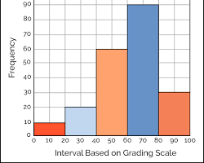Opens in a new window[](https://discovery.cs.illinois.edu/learn/Exploratory-Data-Analysis/Histograms/)illinois.edu](https://discovery.cs.illinois.edu/learn/Exploratory-Data-Analysis/Histograms/)

Histogram example

6. Area Charts:

* Data: Change over time or cumulative values.
* Use Cases:
  + Visualizing rainfall patterns over a year.
  + Comparing total sales of different products.
  + Showing population growth over time.

[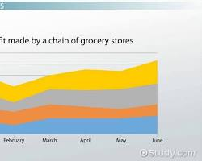Opens in a new window[](https://study.com/learn/lesson/area-chart-definition-examples.html)study.com](https://study.com/learn/lesson/area-chart-definition-examples.html)

Area chart example

7. Heatmaps:

* Data: Variation in intensity across two dimensions.
* Use Cases:
  + Visualizing website user clicks.
  + Showing geographic data like crime rates or population density.
  + Displaying gene expression patterns.

[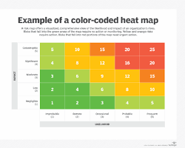Opens in a new window[](https://www.techtarget.com/searchbusinessanalytics/definition/heat-map)techtarget.com](https://www.techtarget.com/searchbusinessanalytics/definition/heat-map)

Heatmap example

8. Treemaps:

* Data: Hierarchical data, part-to-whole relationships.
* Use Cases:
  + Visualizing file structure on a computer.
  + Showing product categories and subcategories in a store.
  + Illustrating organizational structure.

[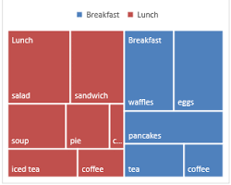Opens in a new window[](https://support.microsoft.com/en-au/office/create-a-treemap-chart-in-office-dfe86d28-a610-4ef5-9b30-362d5c624b68)microsoft.com](https://support.microsoft.com/en-au/office/create-a-treemap-chart-in-office-dfe86d28-a610-4ef5-9b30-362d5c624b68)

Treemap example

9. Box Plots:

* Data: Distribution of data, including outliers.
* Use Cases:
  + Comparing the distribution of test scores between different classes.
  + Analyzing the variability of product prices.
  + Investigating the spread of customer satisfaction ratings.

[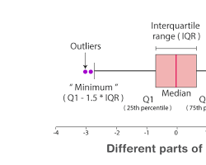Opens in a new window[](https://byjus.com/maths/box-plot/)byjus.com](https://byjus.com/maths/box-plot/)

Box plot example

Remember: The best chart type depends on the specific data you're working.